Machine Learning Algorithms & Evaluation Metrics
We will cover:
- K-Nearest Neighbors (KNN)
- Decision Trees
- Random Forests
- Support Vector Machines (SVM)
- K-Means Clustering
- Principal Component Analysis (PCA)
- Evaluation Metrics
  - Classification
  - Regression
  - Clustering
- How to choose between these algorithms

1. K-Nearest Neighbors — KNN

1.1 What is KNN?
KNN stands for K-Nearest Neighbors.
It is one of the easiest machine-learning algorithms to understand.
The basic idea is:
"Tell me what the nearby examples are, and I'll use them to make my prediction."
Unlike many models, KNN doesn't really learn a complicated mathematical model during training.
Instead, it essentially memorizes the training data.
When a new observation arrives, KNN looks for the observations closest to it.

1.2 Analogy
Imagine you move to a new neighborhood.
You want to know:
"Is this neighborhood expensive or affordable?"
You look at the houses closest to your new house.
Suppose the 5 nearest houses have prices:
₦50m
₦55m
₦48m
₦52m
₦51m
You might conclude:
"This area is probably around ₦50m."
That's the basic intuition behind KNN.

1.3 How KNN Works
Suppose we have:
● Class A

● Class A

? New point

● Class B
● Class B
If we set:
K = 3
KNN finds the three closest points.
Suppose:
2 → Class A
1 → Class B
The majority is Class A.
Therefore:
Prediction = Class A

1.4 What Does K Mean?
K is the number of neighbors we consider.
For example:
K = 1
means:
Look at only the nearest observation.
While:
K = 5
means:
Look at the five nearest observations.

1.5 Small K vs Large K
This is extremely important.

K = 1
The model pays very close attention to individual training examples.
This can lead to:
High variance
and therefore:
Overfitting

Very large K
The model considers many observations.
Predictions become smoother, but the model may ignore local patterns.
This can lead to:
High bias
and therefore:
Underfitting
So KNN has a bias-variance tradeoff too.

1.6 Distance
How does KNN decide which observations are "near"?
Usually through a distance metric.
The most common is Euclidean distance.
For two points:

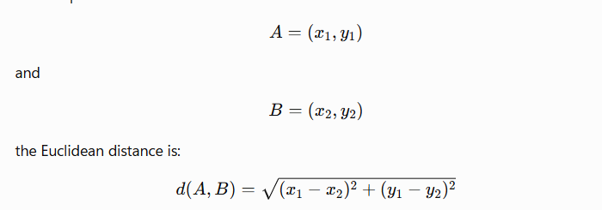Example
Point A:
(2, 3)
Point B:
(5, 7)
Then:

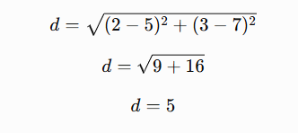

1.7 Why Scaling Is Important for KNN
Suppose we have:
Age: 20–60
Salary: 100,000–10,000,000
Salary has much larger numerical values.
Distance calculations may therefore be dominated by salary.
This is why KNN usually benefits from feature scaling.
For example:
from sklearn.preprocessing import StandardScaler

scaler = StandardScaler()

X_train_scaled = scaler.fit_transform(X_train)
X_test_scaled = scaler.transform(X_test)
Notice:
fit_transform() on training data.
and:
transform() on test data.
We should not fit the scaler using the test data.

1.8 KNN in Python
from sklearn.neighbors import KNeighborsClassifier

model = KNeighborsClassifier(n_neighbors=5)

model.fit(X_train_scaled, y_train)

predictions = model.predict(X_test_scaled)

1.9 When Is KNN Useful?
KNN can be useful when:
- the dataset isn't extremely large
- local similarity is meaningful
- the decision boundary is complicated
- you want a simple baseline
It can struggle when:
- there are many features
- the dataset is huge
- irrelevant features exist
- distances become less meaningful in high dimensions
This connects to a concept called the curse of dimensionality.

2. Decision Trees

2.1 What Is a Decision Tree?
A decision tree makes predictions by asking a sequence of questions.
Think of it as a flowchart.
For example:
Is age > 30?
/ \
Yes No
/ \
Income > ₦200k? No
/ \
Yes No
/ \
Buy Don't Buy
The model repeatedly divides the data using questions.

2.2 Analogy
Imagine diagnosing a disease.
A doctor might ask:
Does the patient have fever?
|
Yes
↓
Does the patient have cough?
|
Yes
↓
Possible respiratory infection
A decision tree works similarly.

2.3 Classification Tree
Suppose we're predicting whether a customer will buy a product.
Features:
Age
Income
Previous purchases
The tree may learn:
Income > ₦500k?
|
Yes
|
Previous purchases > 3?
|
Yes
|
BUY

2.4 How Does a Tree Decide Which Question to Ask?
This is where the mathematics becomes interesting.
For classification, common criteria include:
- Gini impurity
- Entropy / Information Gain

2.5 Gini Impurity
The Gini impurity is:
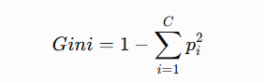
where pip_i is the proportion of observations belonging to class ii.
Suppose a node contains:
50% Cat
50% Dog
Then:
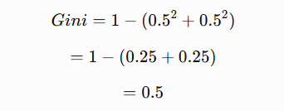
This node is relatively impure.

If a node contains:
100% Cat
0% Dog
then:
Gini=1-(1^2+0^2) =0
A Gini value of zero means the node is perfectly pure.

2.6 Entropy
Another measure is entropy:
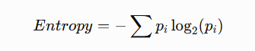
For a perfectly pure node:
100% Cat
entropy is:
0
For a 50/50 split:
50% Cat
50% Dog
entropy is:
1
The tree searches for splits that produce more homogeneous child nodes.

2.7 Why Decision Trees Overfit
Imagine a tree that keeps splitting:
Question 1
↓
Question 2
↓
Question 3
↓
Question 4
↓
Question 5
↓
Question 6
↓
...
Eventually it can create very specific rules for individual training examples.
This produces:
Training accuracy = 100%
Test accuracy = 70%
That's overfitting.

2.8 Controlling Tree Complexity
Important parameters include:
DecisionTreeClassifier(
max_depth=5,
min_samples_split=10,
min_samples_leaf=5
)

max_depth
Controls how deep the tree can become.

min_samples_split
Minimum observations required before a node can be split.

min_samples_leaf
Minimum observations allowed in a leaf.
These parameters are forms of regularization.

2.9 Advantages of Decision Trees
- Easy to interpret
- Can capture nonlinear relationships
- Little preprocessing required
- Doesn't require feature scaling
- Handles numerical and categorical features depending on implementation/preprocessing

Disadvantages
- Can overfit easily
- Individual trees can be unstable
- Small changes in data can produce a different tree
That last problem motivates Random Forests.

3. Random Forest

3.1 What Is a Random Forest?
A Random Forest is essentially:
Many decision trees working together.
Instead of trusting one tree:
Tree
↓
Prediction
we create many trees:
Tree 1 ───┐
Tree 2 ───┤
Tree 3 ───┤
Tree 4 ───┼──→ Final prediction
Tree 5 ───┤
Tree 6 ───┤
Tree 7 ───┘

3.2 Analogy
Imagine asking one doctor:
"What disease does this patient have?"
Then asking 100 doctors.
If 80 say:
Disease A
and 20 say:
Disease B
you might use the majority opinion.
Random Forest uses a similar idea.

3.3 How Random Forest Works
Random Forest uses ensemble learning.
Each tree is trained using some randomness.
Two important sources of randomness are:

1. Bootstrap samples
Each tree gets a randomly sampled version of the training data.

2. Random feature selection
At each split, the tree considers a random subset of features.
This makes the trees different from one another.

3.4 Why Does This Help?
A single decision tree can have high variance.
Suppose:
Tree 1 → 90%
Tree 2 → 70%
Tree 3 → 80%
Tree 4 → 75%
Tree 5 → 85%
Combining many trees tends to make predictions more stable.
This is one reason Random Forest often generalizes better than an unrestricted individual tree.

3.5 Classification
For classification:
Tree 1 → Cat
Tree 2 → Cat
Tree 3 → Dog
Tree 4 → Cat
Tree 5 → Cat
Final:
Cat
because Cat receives the majority vote.

3.6 Regression
For regression, the trees can produce numerical predictions.
For example:
Tree 1 → 50
Tree 2 → 54
Tree 3 → 52
Tree 4 → 56
Tree 5 → 53
Final prediction can be approximately:
50+54+52+56+53/5=53

from sklearn.ensemble import RandomForestClassifier

model = RandomForestClassifier(
n_estimators=100,
max_depth=10,
random_state=42
)

model.fit(X_train, y_train)

predictions = model.predict(X_test)

3.8 Important Random Forest Parameters

n_estimators
Number of trees.
n_estimators=100
means 100 trees.

max_depth
Maximum depth of each tree.

max_features
How many features are considered when finding splits.

min_samples_leaf
Minimum observations in a leaf.

3.9 Random Forest vs Decision Tree
Decision Tree | Random Forest
One tree | Many trees
High variance | Usually lower variance
Can overfit easily | Often more robust
Easier to visualize | Harder to interpret
Faster/simple | More computationally expensive

4. Support Vector Machine — SVM
SVM is one of the most important classical machine-learning algorithms.
The basic idea is:
Find a boundary that separates classes while maximizing the margin between them.

4.1 Simple Example
Imagine two groups:
● ● ● ●

| boundary |

○ ○ ○ ○
Many lines could separate them.
SVM tries to find the boundary with the largest margin.

4.2 What Is the Margin?
Imagine:
● ● ● | ○ ○ ○
● ● ● | ○ ○ ○
The margin is the distance between the decision boundary and the closest training points from each class.
The closest points are called:
Support vectors
Hence the name:
Support Vector Machine.

4.3 Why Maximize the Margin?
Suppose we have:
Boundary A

● ● | ○ ○
and:
Boundary B

● ● | ○ ○
Boundary B has a larger margin.
The intuition is that a larger margin can make the classifier less sensitive to small variations in the data.

4.4 Mathematical Idea
For a linear classifier:
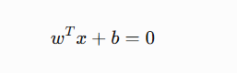
where:
- w = weight vector
- x = input
- b = bias
SVM attempts to find a boundary that separates classes while maximizing the margin.
The distance from a point to the hyperplane is related to:
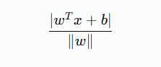

4.5 What If Data Isn't Linearly Separable?
Real datasets are often not separable with a straight line.
SVM can use something called a:
Kernel
A kernel allows SVM to model nonlinear relationships.
Common kernels include:
- Linear
- Polynomial
- RBF
- Sigmoid
The RBF kernel is particularly common for nonlinear problems.

4.6 Kernel Intuition
Imagine:
○ ○
○ ○

●
● ●
A straight line might not separate them.
A nonlinear transformation can make the groups separable in another feature space.
This is related to the famous:
Kernel trick

4.7 SVM Parameters
Two particularly important parameters are:

C
Controls the tradeoff between:
- having a wide margin
- correctly classifying training observations
High C:
Penalize classification errors more strongly.
Lower C:
Allow more errors in exchange for a potentially wider margin.

Gamma
Important for RBF kernels.
It controls how strongly an individual training example influences the decision boundary.
Very high gamma can produce a highly complex boundary.
That can lead to overfitting.

4.8 SVM Requires Feature Scaling
SVM generally benefits from scaling.
from sklearn.preprocessing import StandardScaler
from sklearn.svm import SVC

scaler = StandardScaler()

X_train_scaled = scaler.fit_transform(X_train)
X_test_scaled = scaler.transform(X_test)

model = SVC(
kernel="rbf",
C=1,
gamma="scale"
)

model.fit(X_train_scaled, y_train)

predictions = model.predict(X_test_scaled)

4.9 When Is SVM Useful?
SVM can work very well when:
- dataset size is moderate
- feature dimensions are relatively high
- classes have meaningful boundaries
- appropriate scaling and kernels are used
It can become expensive on very large datasets.

5. K-Means Clustering
Now we move from supervised to unsupervised learning.
K-Means asks:
"Can I divide these observations into K groups based on similarity?"

5.1 Example
Suppose we have customers:
Spending
↑
|
| ● ●
| ● ●
|
| ● ●
| ● ●
+----------------→ Income
We might discover two groups:
Group 1 → Low income / low spending
Group 2 → High income / high spending
We did not provide those labels.
The algorithm discovered them.

5.2 Why Is It Called K-Means?
Because:
K = number of clusters
Means = each cluster is represented by its mean/centroid.
Suppose:
K = 3
The algorithm tries to find:
Cluster 1
Cluster 2
Cluster 3

5.3 How K-Means Works
The algorithm roughly follows these steps.

Step 1
Choose K.
For example:
K = 3

Step 2
Initialize three centroids.
Centroid A
Centroid B
Centroid C

Step 3
Assign every observation to its nearest centroid.

Step 4
Calculate the new mean of each cluster.

Step 5
Move the centroids to those means.

Step 6
Repeat.
The algorithm stops when the assignments/centroids stabilize or a stopping criterion is reached.

5.4 Simple Analogy
Imagine throwing 100 students into a room and asking:
"Divide yourselves into three groups where people in the same group are as similar as possible."
People might naturally form groups.
K-Means does something similar mathematically.

5.5 Python
from sklearn.cluster import KMeans

model = KMeans(
n_clusters=3,
random_state=42,
n_init="auto"
)

clusters = model.fit_predict(X)

print(clusters)
The output might look like:
[0, 0, 1, 2, 1, 0, 2, ...]
These numbers are cluster IDs, not necessarily meaningful class labels.
Cluster 0 does not inherently mean "good."

5.6 Choosing K
One common approach is the:
Elbow Method
We calculate the within-cluster sum of squares for different values of K.
Conceptually:
Error
↑
|\
| \
| \
| \__
| \____
+----------------→ K
↑
elbow
The "elbow" can provide a useful candidate for K.
However, it is not an absolute rule.

5.7 K-Means Limitations
K-Means can struggle when:
- clusters have unusual shapes
- clusters have very different sizes
- clusters have different densities
- outliers are present
- features aren't appropriately scaled
It also requires you to choose K.

6. PCA — Principal Component Analysis
PCA is another unsupervised learning technique.
Its main goal is:
Reduce the number of dimensions while retaining as much useful variation as possible.

6.1 Why Do We Need PCA?
Imagine a dataset containing:
100 features
Visualizing that is difficult.
PCA might reduce:
100 dimensions
↓
2 dimensions
Then we can visualize the observations.

6.2 Analogy
Imagine you have a 3D object.
You shine a light onto a wall.
The object creates a 2D shadow.
The goal is to choose a projection that preserves as much important information as possible.
PCA does something conceptually related to this.

6.3 What Is a Principal Component?
A principal component is a direction in feature space that captures variation in the data.

First Principal Component
The direction that captures the greatest variance.

Second Principal Component
The next direction that captures the greatest remaining variance while being orthogonal to the first.
And so on.

6.4 Example
Suppose:
Height
↑
| ●
| ●
| ●
| ●
| ●
+----------------→ Weight
Height and weight are correlated.
Instead of treating them as two completely independent directions, PCA can find a new axis that captures most of the variation.

6.5 PCA Mathematics
PCA is closely related to:
- covariance
- eigenvectors
- eigenvalues
Suppose we have a covariance matrix:
Σ\Sigma
PCA finds eigenvectors:
Σv= λv
where:
- v = eigenvector
- λ = eigenvalue
The eigenvectors determine the principal directions.
The eigenvalues indicate how much variance is associated with those directions.

6.6 Explained Variance
Suppose PCA produces:
PC1 → 70%
PC2 → 20%
PC3 → 7%
PC4 → 3%
Then the first two components explain:
70+20=90%
of the variance.
We might therefore retain only two components.

6.7 Python PCA
from sklearn.preprocessing import StandardScaler
from sklearn.decomposition import PCA

scaler = StandardScaler()

X_scaled = scaler.fit_transform(X)

pca = PCA(n_components=2)

X_pca = pca.fit_transform(X_scaled)

print(pca.explained_variance_ratio_)
For example:
[0.72, 0.21]
means:
PC1 → 72%
PC2 → 21%
Together:
93%
of the variance is explained.

6.8 Why Scale Before PCA?
Suppose:
Age: 20–80

Income: 100,000–10,000,000
Income may dominate the variance simply because of its scale.
Therefore, PCA commonly follows:
Raw Data
↓
Standardization
↓
PCA

6.9 PCA Applications
PCA can be used for:
- visualization
- dimensionality reduction
- noise reduction
- preprocessing
- exploratory data analysis
- reducing computational complexity
But PCA can reduce interpretability because the new components are combinations of the original features.

7. Evaluation Metrics
Training a model is only half the job.
We need to answer:
How well is the model performing?
The appropriate metric depends on the problem.

7.1 Classification Metrics
Let's start with a binary classification problem:
Disease
The model predicts:
Positive
Negative

8. Confusion Matrix
The confusion matrix is the foundation of many classification metrics.
 | Actual Positive | Actual Negative
Predicted Positive | TP | FP
Predicted Negative | FN | TN

Where:

TP — True Positive
Predicted positive and actually positive.

TN — True Negative
Predicted negative and actually negative.

FP — False Positive
Predicted positive but actually negative.

FN — False Negative
Predicted negative but actually positive.

9. Accuracy
Accuracy measures the proportion of all predictions that are correct.
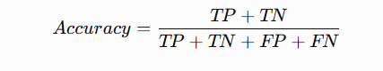
Example:
TP = 80
TN = 90
FP = 10
FN = 20
Then:
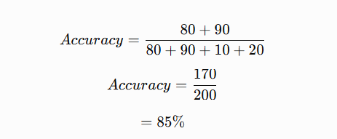

9.1 The Problem With Accuracy
Suppose we have 1,000 patients:
990 → Negative
10 → Positive
A terrible model predicts:
Everyone = Negative
Accuracy:
990/1000=99%990/1000=99\%
Sounds excellent.
But the model detected:
0/10 positive patients
So accuracy alone can be misleading with imbalanced datasets.

10. Precision
Precision answers:
Of everything the model predicted as positive, how many were actually positive?
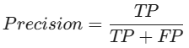
Imagine a fraud detector.
If it flags 100 transactions as fraud and only 70 really are fraud:
Precision=70%
High precision means fewer false positives among predicted positives.

11. Recall
Recall answers:
Of all the actual positive cases, how many did the model find?
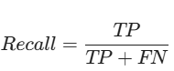
Suppose there are 100 actual cancer cases.
The model detects 90.
Then:
Recall=90%Recall=90\%
Recall is especially important when missing a positive case is costly.

12. Precision vs Recall
Think about a medical screening system.

High recall
You want to catch as many actual cases as possible.
But you may generate more false alarms.

High precision
When the model says:
"Positive"
you want to be confident that it really is positive.
But you might miss more actual positives.
Neither metric is universally "better"; the appropriate emphasis depends on the application's costs and consequences.

13. F1 Score
F1 combines precision and recall using their harmonic mean:
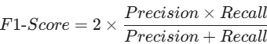
Suppose:
Precision = 0.80
Recall = 0.60
Then:
F1=20.80×0.600.80+0.60F1 = 2\frac{0.80\times0.60}{0.80+0.60} F1≈0.686F1\approx0.686
So:
F1 ≈ 68.6%
F1 is useful when we want a balance between precision and recall.

14. Specificity
Specificity measures the ability to correctly identify negative cases.
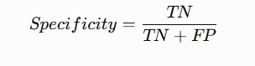
Another way to remember:
Recall → How many positives did we find?

Specificity → How many negatives did we correctly reject?

15. ROC Curve and AUC
ROC stands for:
Receiver Operating Characteristic
It examines model performance across different classification thresholds.
The ROC curve plots:
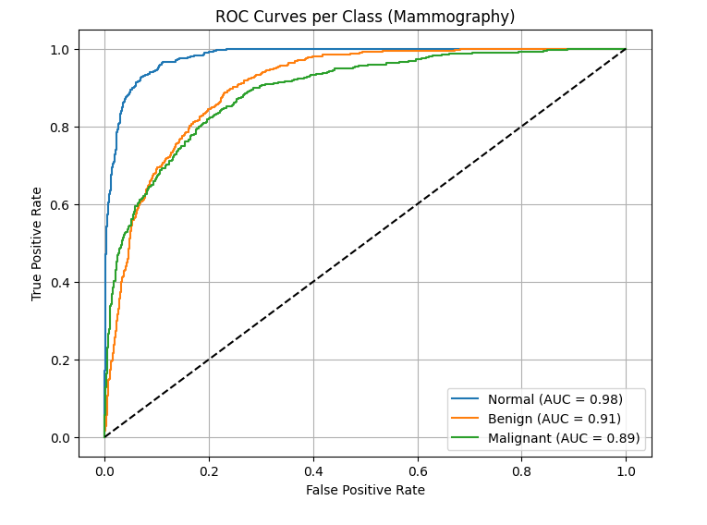

TPR
against:
FPR
where:
TPR=Recall
and:
FPR=FP / FP+TN

AUC
AUC means:
Area Under the ROC Curve
Conceptually:
AUC ≈ 1.0
means excellent ranking/separation.
AUC ≈ 0.5
means performance is roughly comparable to random ranking in the standard binary setting.
AUC is especially useful because it evaluates ranking across thresholds rather than one fixed threshold.

16. Precision-Recall Curve
For highly imbalanced problems, a Precision-Recall curve can be particularly informative.
For example:
Fraud detection
where:
99.5% → legitimate
0.5% → fraud
ROC-AUC can sometimes appear strong even when positive-class performance is not satisfactory.
Precision-Recall analysis focuses more directly on positive predictions and positive cases.

17. Multiclass Classification
Suppose your model predicts:
Normal
Benign
Malignant
We can calculate precision, recall, and F1 for each class.
Example:
Class | Precision | Recall | F1
Normal | 0.87 | 0.75 | 0.81
Benign | 0.77 | 0.60 | 0.68
Malignant | 0.64 | 0.83 | 0.72
This gives much more information than a single accuracy number.

18. Macro vs Weighted Average
This is particularly important for imbalanced datasets.

Macro Average
Calculate the metric for each class and then give every class equal weight.
For three classes:

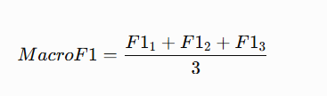

Weighted Average
Weights each class according to its number of samples.
So a class with 10,000 examples contributes more than a class with 100 examples.

19. Regression Metrics
For regression, we aren't predicting classes.
We're predicting numbers.
Important metrics include:
- MAE
- MSE
- RMSE
- R2R^2

20. MAE — Mean Absolute Error
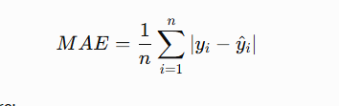
Suppose actual values are:
100
200
300
Predictions:
110
190
320
Errors:
10
10
20
Therefore:
MAE=10+10+20/3=13.33
Interpretation:
On average, predictions are about 13.33 units away from the actual values.

21. MSE — Mean Squared Error
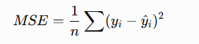
Because errors are squared, large errors receive much greater penalty.
This makes MSE sensitive to outliers.

22. RMSE
RMSE is:
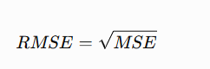One advantage is that RMSE is expressed in the same units as the target.
For example:
Target = house price in ₦millions
RMSE is also expressed in ₦millions.

24. Clustering Evaluation
K-Means doesn't have traditional labels.
So how do we evaluate it?
Some common metrics include:

Silhouette Score
It measures how well each observation fits within its own cluster compared with neighboring clusters.
Its range is approximately:
−1→1
Higher values generally indicate better-separated clusters.

Inertia
K-Means minimizes within-cluster squared distances.
In scikit-learn:
model.inertia_
Lower inertia means points are closer to their assigned centroids, but inertia almost always decreases as K increases.
Therefore, you shouldn't choose K solely because it has the lowest inertia.
This is why the elbow method can be useful.

25. Evaluation Metrics in Python
For classification:
from sklearn.metrics import (
accuracy_score,
precision_score,
recall_score,
f1_score,
confusion_matrix,
classification_report
)

print("Accuracy:", accuracy_score(y_test, predictions))

print("Precision:",
precision_score(y_test, predictions,
average="weighted"))

print("Recall:",
recall_score(y_test, predictions,
average="weighted"))

print("F1:",
f1_score(y_test, predictions,
average="weighted"))

print(confusion_matrix(y_test, predictions))

print(classification_report(y_test, predictions))

26. Regression Evaluation in Python
from sklearn.metrics import (
mean_absolute_error,
mean_squared_error,
r2_score
)

mae = mean_absolute_error(y_test, predictions)

mse = mean_squared_error(y_test, predictions)

rmse = mse ** 0.5

r2 = r2_score(y_test, predictions)

print("MAE:", mae)
print("MSE:", mse)
print("RMSE:", rmse)
print("R2:", r2)

27. Comparing the Algorithms
Algorithm | Type | Scaling Usually Important? | Main Idea
KNN | Supervised | Yes | Nearby observations vote
Decision Tree | Supervised | No | Sequential decision rules
Random Forest | Supervised | Usually no | Ensemble of trees
SVM | Supervised | Yes | Maximum-margin boundary
K-Means | Unsupervised | Usually yes | Group observations around centroids
PCA | Unsupervised | Usually yes | Find directions of maximum variance

28. When Should You Use Which?

KNN
Use when:
- similarity/local neighborhoods matter
- dataset isn't extremely large
- you want a simple baseline

Decision Tree
Use when:
- interpretability matters
- nonlinear relationships exist
- you need understandable decision rules

Random Forest
Use when:
- you want a strong general-purpose tabular baseline
- nonlinear relationships exist
- you want more robustness than a single tree

SVM
Consider when:
- the dataset is moderate in size
- high-dimensional features are useful
- a clear separating boundary exists
- scaling and kernel selection are handled appropriately

K-Means
Use when:
- you don't have labels
- you want to discover groups
- clusters are reasonably compatible with the algorithm's assumptions

PCA
Use when:
- you have many features
- you want visualization
- you want dimensionality reduction
- correlated features create redundancy

29. The Big Picture
These algorithms aren't isolated concepts.
They fit into a larger ML workflow:
DATA
↓
Data Preparation
↓
Train / Test Split
↓
┌────────┴─────────┐
↓ ↓
Supervised Unsupervised
↓ ↓
┌───────┼───────┐ ┌───┴────┐
↓ ↓ ↓ ↓ ↓
KNN Trees SVM K-Means PCA
│ │ │ │ │
└───────┴───────┘ │ │
↓ ↓ ↓
Predictions Clusters Components
↓
Evaluation
↓
Generalization?
↓
Model Improvement

The most important mental model
Don't memorize these algorithms as isolated formulas.
Understand the question each one is trying to answer:
- KNN: "What are the closest examples, and what do they tell me?"
- Decision Tree: "What sequence of questions best separates the data?"
- Random Forest: "What happens if many different trees vote together?"
- SVM: "What boundary separates the classes with the largest margin?"
- K-Means: "Which observations naturally belong together?"
- PCA: "What directions capture most of the variation in my data?"
- Evaluation metrics: "How well does my model actually perform, and what kind of errors does it make?"

